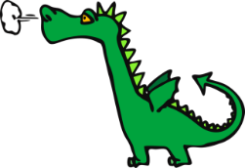
Emily Dickinson Elementary
First Grade School Supply List 2022-2023

*Please bring your school supplies to your classroom!

□ 1 packet of 12 Dixon Ticonderoga #2 pencils
□ 4 low odor dry erase white board markers
□ 8 glue sticks
□ 2 black felt tip flair pens
□ 1 box of 48 crayons
□ Crayola 10 count washable markers (classic colors)
□ Children’s metal pointed scissors
□ 1 pink eraser
□ 1 spiral notebook
□ 1 composition notebook
□ 1 laminated folder with two pockets at the bottom
□ 1 red two pocket folder
□ 1 yellow two pocket folder
□ 1 bottle of Elmer’s liquid school glue 4 fluid ounces
□ Crayola 8 color assorted watercolor paint
□ Headphones to keep at school (please no earbuds)

