Kindergarten Supply List 2021-2022
Purchase the school supplies for your child from the supply list BELOW & on the BACK.
All students should bring:
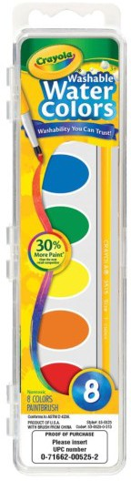
- 1 backpack (no wheels) must be large enough to hold a 3 ring binder.

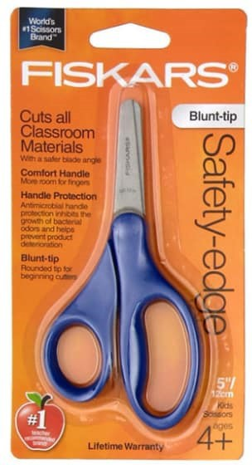
Individual Supplies: Label each item with Child’s Name
- 1 spiral notebook (70 sheet—wide ruled)
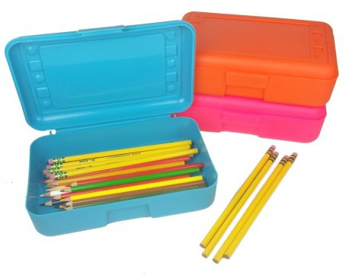
- 1 pair of Fiskars child scissors– blunt tip
- 1 set of Crayola 8 washable watercolor

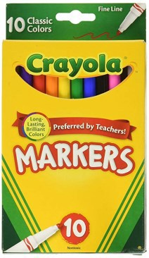
1 pencil box– As in picture
- 1 box of 24 Crayola crayons
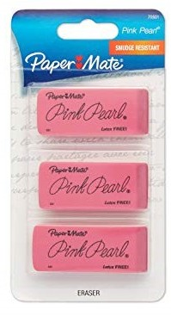
- 10 pack of Crayola washable Fine Line markers
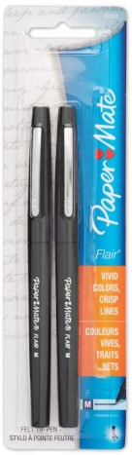
- 2 black flair pens (Paper Mate Flair – not ball point)
- 3 Pack of large pink erasers
- 3 Pack of 22g Elmer's glue sticks washable (purple disappearing)

- 1X12 Pack of #2 pencils (Ticonderoga brand & Pre- sharpened please)
- 12 pack of Crayola colored pencils
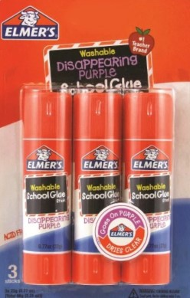
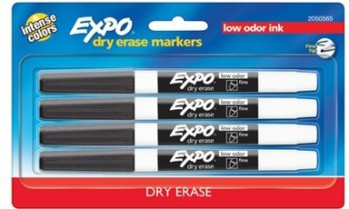
- 2 or 4 Pack of Fine Tip Expo whiteboard markers
- 1 8oz bottle of hand sanitizer (OPTIONAL)

List continues on back

Communal Supplies: These are optional items to donate to the classroom.
- 1 box of Ziplock bags (Boys bring sandwich size & Girls bring gallon size)
-

If you need help getting school supplies please contact our School Counselor Mr. Mendoza ( lmendoza@lwsd.org) or our Office Manager (425-936-2530) can help.

*** Please bring supplies to school during our
WAKIDS Connection meetings

